1. PROJECT DESCRIPTION AND SCOPE

1.1. PROJECT BACKGROUND

Gardabani Wastewater Treatment Plant (WWTP) is located south-east of the city Tbilisi and treats domestic and industrial effluents of Tbilisi, Gardabani and Rustavi. Wastewater from Tbilisi is conveyed by a main collector of 3,300 mm in diameter and, following treatment, discharged into the Mtkvari River.

The plant was built in 1985. Since then, some rehabilitation works were implemented (e.g., primary tanks rehabilitation). At the moment the wastewater treatment is solely conducted through mechanical primary treatment. After passing the primary treatment stage the wastewater is directly discharged into the outlet. The biological treatment stage and secondary clarifiers have not been in operation for at least 25 years. Anaerobic sludge digesters, as well, were build, but never commissioned.

In this case, the project is focus on the dewatering facility of the plant.

1.2. PROJECT OBJECTIVE

The objective of this project is to develop the dewatering facility needed to treat the sludge of the plant, achieving with this process at least, a 25% of dryness and its subsequent stabilisation.

For this project, 2 different scenarios will be studied:

• Current stage
• First extension stage

1.3. CONSIDERATIONS Current stage:
• Inlet sludge flow: 640 m3/d
• Sludge stabilization: by quicklime (250 kg/t DS)
• Type of dewatering equipment: centrifugal decanter (1+0)
• Location: existing garage in fine screen building
• Odor facility: the existing deodorization system is used
• Maintenance tasks: the existing bridge crane is used
• No geotechnical problems are expected. A geotechnical campaign should be carried out, with boreholes located in the current working area
• Service and drinking water intake is avalaible be in the existing building

First extension stage:

• Inlet sludge flow: 1,198.81 m3/d
• Sludge stabilization by: quicklime (150 kg/t DS)
• Type of dewatering equipment: centrifugal decanters (2+1)
• Location: Existing garage in fine screen building
• Odor facility: the existing deodorization system is used
• Maintenance tasks: the existing bridge crane is used

The sludge dewatering facility mainly consists of the following units:

• Feeding sludge buffer tank
• Feeding pumps to sludge dewatering unit
• Sludge dewatering facilities
• Lime storage and dosing equipment
• Dewatered sludge containers
• Electrical works
• Implementation in existing SCADA system

Considering that the full system must be integrated into the existing Wastewater Treatment
Plant.

2. DESCRIPTION OF THE EXISITNG PLANT

Rehabilitation works were implemented completely in 2018 including the inlet chamber, grid and grease removal and the reconstruction of five primary clarifier/sedimentation tanks, which enabled the separation of suspended particles. When the rehabilitation works had been implemented, also a SCADA system has been installed for the WWTP.

Gardabani Wastewater Treatment Plant (WWTP) is composed of:

• Suction chamber
• Distribution chamber
• Coarse screens (5 lines)
• Grid and grease removal (1st stage biological treatment)
• Primary clarifiers of 49.5 m in diameter (5 tanks)
• RAS & WAS pumping station
• Sludge thickener
• Aerobic digestion (out of service)
• Sludge drying beds

Currently, sludge is disposed in drying beds as there is not a sludge mechanical dewatering.

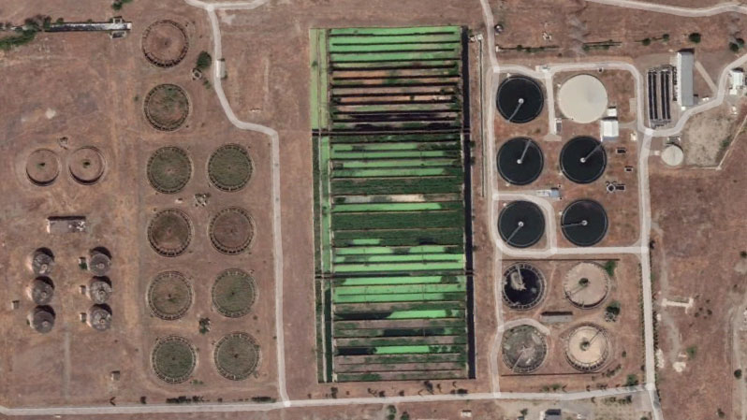

Figure 1 Gardabani WWTP

3. DESIGN DATA

3.1. SLUDGE DEWATERING CHARACTERISTICS

The sludge dewatering characteristics, considering the 2 different scenarios, are summarized below:

STAGE DESCRIPTION
Unit Current First extension
Thickened sludge | Kg/day | 25.600 | 47.952
Flow of sludge to dewatering unit | m3/d | 640 | 1,198.81
Type |  | Centrifuges | Centrifuges
Dry solids content of feeding sludge | % | 4 | 4
Operation time weekly | d/w | 7 | 7
Operation time daily | h/d | 16 | 16
Number of units |  | 1 | 2+1
Type of feeding pumps |  | Progressive  cavity pump | Progressive  cavity pumps
Number of feeding pumps |  | 1+1 | 2+1
Flocculation agent |  | Solid  polymer | Solid polymer
Number of polymer preparation units |  | 1 | 1
Number of dosing pumps for sludge  dewatering |  | 1+1 | 2+1
Type of polymer dosing pumps |  | Progressive  cavity pumps | Progressive cavity pumps

3.2. SLUDGE DEWATERING TREATMENT REQUIREMENTS

The final sludge dewatering treatment requirements are summarized below. Complete process calculations are included in document GA-CAL-PR-10-00001.

STAGE

DESCRIPTION Unit First
Current extension
Sludge stabilization |  | Quicklime | Quicklime
Minimum dry content the  thickened excess sludge | % | 4 | 4
Polymer dose for sludge dewatering | kg/t dry  matter | 10 | 10
Quicklime dose for  stabilization | kg/t D.S | 250 | 125
Dry solids content in dewatered  sludge | % | ≥ 25 | ≥ 25

4. GENERAL DESCRIPTION

In the following sections, a general description of the adopted dewatering sludge treatment, considering 2 different scenarios is described. In section 5, a detailed description of all the dewatering facilities is given.

4.1. JUSTIFICATION

Wastewater sludge dewatering on drying beds was one of the earliest methods to reduce the water content of sludge. The rehabilitation works of the WWTP started with its necessary studies in 2016 and was completed in 2018. The updated average flow throughput of the station with the updated design is 5.5 m3/s, being insufficient the volume of the drying beds. In addition, this increasing flow causes a massive odour problem.

A dewatering sludge process improves the performance of the wastewater treatment plants in different ways, such as:

• The volume of the sludge production is less than volume without a mechanical dewatering process, increasing its dryness from 4% to 25%. This point is important because, the costs associated to the sludge storage and transportation (operation costs) are going to be less.
• In both scenarios, dewatering process includes a sludge stabilization by using quicklime dosing. This stabilization process reduces the sludge odor and the focus of the attraction when the sludge is disposed at the storage area.

For these reasons, with the current and future flows, a dewatering facility and a sludge stabilization are the optimal solutions.

4.2. DEWATERING SYSTEM. CURRENT STAGE General process description:
Feeding sludge buffer tank:

The incoming flow from the existing thickened primary sludge pumping station goes to the new feeding sludge buffer tank, located next to existing fine screen building and with a volume of 145.75 m3 and a retention time of 5.47 h. This buffer tank is equipped with a submersible mixer.

Feeding pumps to sludge dewatering unit:

Next to the buffer tank, a new feeding pumping station in dry pit is designed to feed the dewatering facility.

This pumping station is equipped at this stage, with 1 (on duty) +1 (on standby) progressive cavity pumps, with a unitary capacity of 45 m3/h, a pressure of 10 w.c.m. and unitary power of 9.2 kW.

Centrifugal decanter:

Dewatering facility is located in the existing garage, that it is inside the fine screen building. In this stage, it is proposed to install one (1+0) centrifuge, with capacity to treat a unitary flow of 45 m³/h and 1600 kg ds/h.

The objective is to perform the dewatering of sludge by means of centrifuges; it is expected to obtain a sludge concentration at the output over or equal than 25%.

The dewatering facilities have been designed for the sludge loads that are produced in the treatment plant, with capacity for their treatment in an operating period of seven 7 days a week, sixteen 16 hours a day at average flow conditions.

For the chemical conditioning of this type of sludge, cationic polyelectrolyte is used.

The centrifuge is a unit that separates the solid from the liquid phase in the floccular sludge by taking advantage of the centrifugal force that is obtained by rotating at high speed.

Dewatered sludge at 25 % dryness will be discharged into a 3.50 m length screw conveyor. This discharges into a double shaft mixer with 7 m³/h of capacity to be mixed with quicklime, in order to stabilize the sludge and increase its dryness percentage.

Throughout the dewatering process using centrifuges, the sludge being treated is totally enclosed and there are no aggressions to the surroundings that impair the personnel's working conditions.

Dewatered overflow goes to the fine screen channels by gravity for its further treatment. For the maintenance of the equipment, the existing bridge crane is used.
Polyelectrolyte dosage:

Cationic polyelectrolyte is used for chemical conditioning of this type of sludge.

It is estimated a dose of 8 kg polyelectrolyte/t (average conditions) and 10 kg polyelectrolyte/t
(max. conditions)

The reagent is prepared in three automatic continuous-mode production installations that consists of a vat with three compartments, two of them with agitation. The polyelectrolyte is dosed in powder form by means of a dosage screw that includes a storage hopper of 100 liters.

With each unit a continuous unitary production of 0.5% polyelectrolyte is achieved at 8,000 l/h.

The dosage will be carried out by means of two (1+1) progressive cavity pumps; with a flow of 1,400 - 3,700 l/h and 10 w.c.m. o pressure. All pumps will be equipped with variable frequency converters.

Water is incorporated in the discharge of the dosage pumps to dilute the reagent to 0.2% and the dilution flow is regulated by means of in-line rotameters.

The polyelectrolyte is dosed in the sludge intake pipes to the centrifuges.

Lime stabilization

Dewatered sludge (sludge cake) is stabilized by the addition of lime powder. The lime mixing, dosing and storage plant consists of one storage silo, one arch breaker inside silos’ conical bottom, one screw conveyors with 400 kg/h unit capacity equipped with VFD’s and ancillary elements.

Lime storage is carried out in vertical steel made silo specially designed to handle lime powder. An inner mechanism avoids arch formation in conical bottom and feed the screw dosing conveyor to deliver powder into lime injector over mixer.

The dewatered sludge cake from the centrifuge is mixed with the lime powder in order to stabilize the sludge, the lime has a sterilization effect, by increasing of sludge pH. Furthermore, it increases the dry solids content for additional 8 – 10 %.

One lime silo, with a capacity of 42 m³ is foreseen for the storage of the lime. Lime is mixed via double shaft mixer into dewatered sludge coming from centrifuges, the mixer capacity is 7 m3/h. The silo is equipped with overpressure safety device, level indication and control, dust removal filter, and silo arch breaker.

Lime dose is 250 kg/t D.S, with a storage time of 5 days.

Transport of dewatered sludge to storage area:

From cake and lime mixer outlet, one 11 m length inclined screw conveyor, convey stabilized sludge to another 3 m length pivoting screw conveyor with two discharge points that delivers dried sludge into two 20 m³ containers, that they will be delivered to drying beds.
4.3. DEWATERING SYSTEM. FIRST EXTENSION STAGE General process description:

For this stage, the facilities built and equipped for the current stage (section 4.2) are going to be the same but adding more dewatering capacity.

The main difference between both stages the inlet sludge flow.

Feeding sludge buffer tank:

The incoming digested sludge flow from the anaerobic digester goes to the new feeding sludge buffer tank, located next to existing fine screen building and with an available volume of 145.75 m3 and a retention time of 2.92 h. This buffer tank is equipped with a submersible mixer.

Feeding pumps to sludge dewatering unit:

This pumping station increases its capacity with a new pump progressive cavity pump, 2 (on duty) +1 (on standby), with a unitary capacity of 45 m3/h, a pressure of 10 w.c.m. and unitary power of 9.2 kW.

Centrifugal decanter:

As well as the section 4.2, the same dewatering facility is used, but adding two new centrifuges, being the final disposal of the installation, three (2+1) centrifuges, with capacity to treat a unitary flow of 45 m³/h and 2997.01 kg ds/h.

Dewatered sludge at 25 % dryness will be discharged into a 9.50 m length screw conveyor. This discharges into a double shaft mixer with 11 m³/h of capacity to be mixed with lime, in order to stabilize the sludge and increase the dryness percentage.

Polyelectrolyte dosage:

For this stage, the equipment of the polyelectrolyte dosage is the same as section 4.2 but increasing the dosing capacity with a new progressive cavity pump, three (2+1) with the same characteristics.

Lime stabilization

The lime stabilization facility is the same as in section 4.2 but with a different lime dosing. In this case, the anaerobic digestion is available, so the lime dosing in this stage is around 125 kg/t D.S, with a storage time of 6 days.

The dewatered sludge flow is higher than in the “current stage”, so that the mixer is replaced by a new one with a capacity of 11 m3/h.

Transport of dewatered sludge to storage area:

Due to the process, the dewatered sludge flow obtained is 10.77 m³/h. So, the same equipment installed in “current stage” has the enough capacity to transport it, and therefore is not necessary increase it.

4.4. GENERAL LAYOUT

4.4.1. Current stage layout

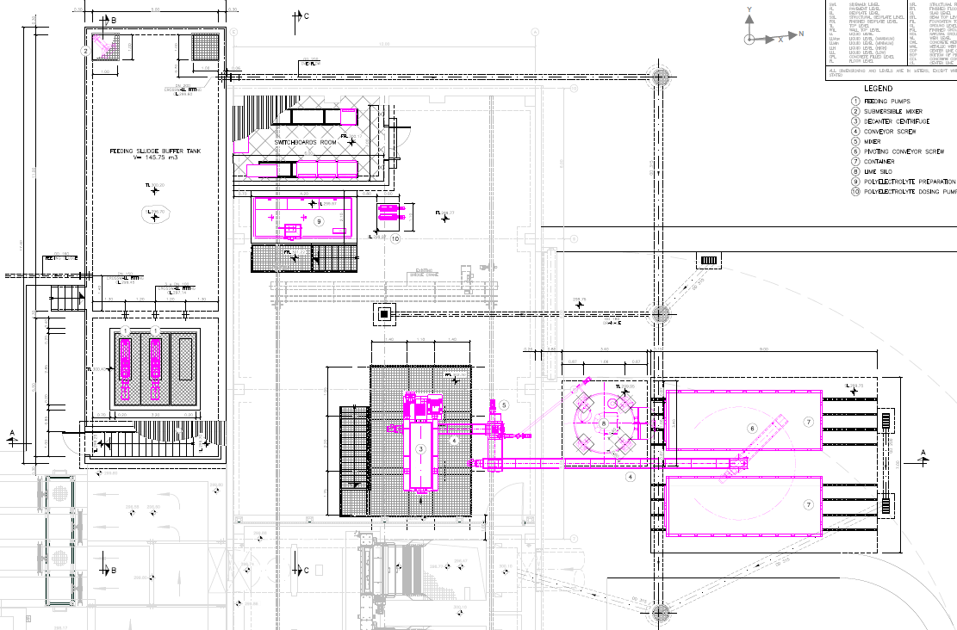

4.4.2. First extension stage layout

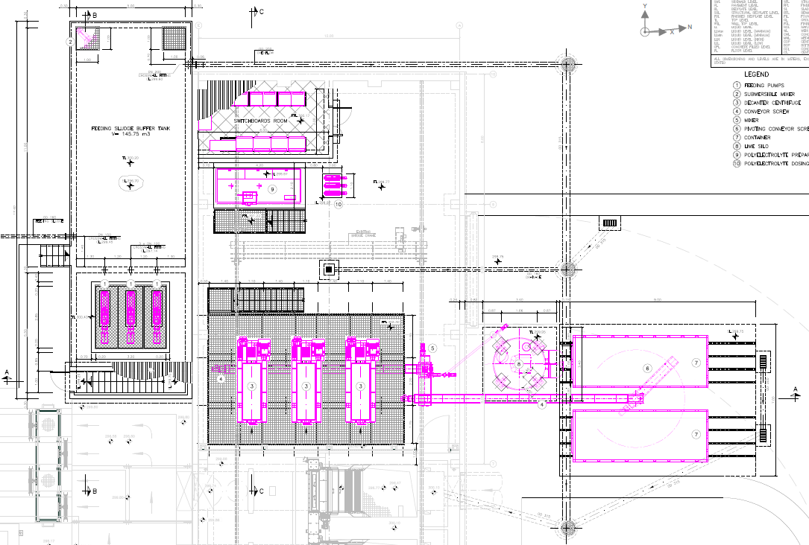

5. DESCRIPTION OF FACILITIES

5.1. FEEDING SLUDGE BUFFER TANK

For the feeding sludge to dewatering unit, a buried buffer tank will be constructed with a volume of 145.75 m3. With the following dimensions:

• L= 11 m
• W= 5 m
• H = 3.50 m
• Max. filling level 2.65 m

The dimensions of the buffer tank are the same for both stages.

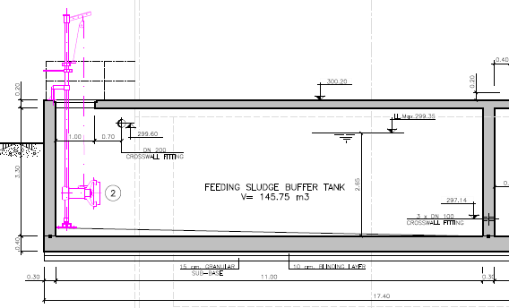

This buffer tank is located next to the fine screen building and it is equipped with a submergible mixer with a power of 1.5 kW. From this buffer tank the feeding pumps will suck.

To have an access, a metallic cover (1.00 x1.00 m) on the top of the slab is considered.

This tank is fed by a buried OD160 PE pipe, in addition, it is equipped with a safety overflow
OD200 PE pipe.

As mentioned before, this buffer tank has a retention time of 5.47 h in “current stage” and
2.92 h in “first extension stage”.

5.2. FEEDING PUMPS TO SLUDGE DEWATERING UNIT

A new feeding pumping station is designed next to the buffer tank, its dimensions are:

• L = 5.50 m
• W = 5.00 m
• H = 3 m

The dimensions of the pumping station are the same for both stages.

It is equipped with progressive cavity pumps placed on concrete bedplates:

• 2 (1+1) in “current stage”
• 3 (2+1) in “first extension stage”

With the following characteristics:

• Unitary flow: 45 m3/h,
• Pressure: 10 w.c.m.
• Unitary power: 9.2 kW.

These pumps will be equipped with an electronic frequency converter, so that the flow to the dewatering equipment can be adjusted from the control panel.

To access to the pumps, a concrete stair is foreseen, and to extract the pumps for maintenance tasks, there is a removable galvanized steel cover (2.85 x 3.20 m) on the top of slab.

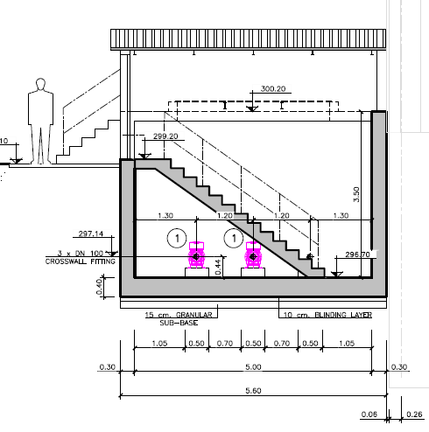

5.3. CENTRIFUGAL DECANTER

All centrifugal decanters and their associated equipment are located in the garage of the existing fine screen building.

Current stage:

The objective is to perform the dewatering of sludge by means of centrifuges; it is expected to obtain a sludge concentration at the output over or equal than 25%.

In this stage, it is proposed to install (1+0) centrifuge, which technical characteristics are:

• Number of equipment: 1 (1+0) unit
• Sludge concentration: 4 %
• Cake solids: 25%
• Volumetric max. flow: 45 m³/h
• Solid max flow: 1,600 kg solids/h
• Bowl diameter: 570 mm
• Main drive/centrifuge: 45 kW.
• Back drive: 15 kW.
• Main material: Duplex stainless steel

Dewatered sludge at 25 % dryness will be discharged into a 3.50 m length screw conveyor. This discharges into a double shaft mixer with 7 m³/h of capacity to be mixed with lime.

Centrifuge is installed in a steel platform with the following dimensions:

• L =4 m
• W = 5.9 m
• H = 2.5 m

Through a steel stair, the top of the platform, where the centrifuge is installed, is reached. The same steel stair will be used for the “first extension stage”.

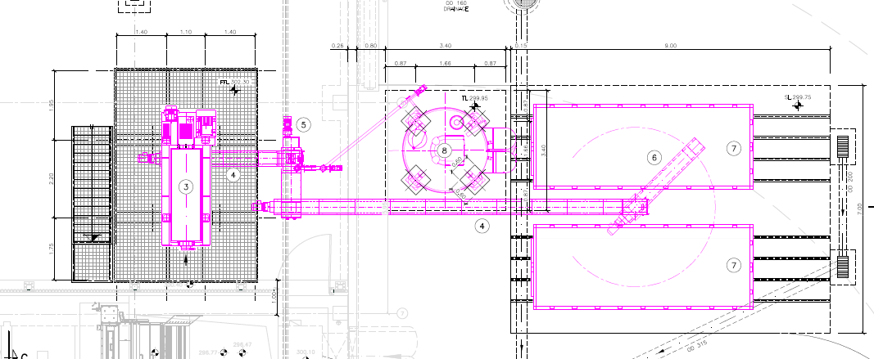

First extension stage:

As mentioned before, the dewatering capacity is increased with 2 new centrifuges, being its final disposal as:

• Number of equipment: 3 (2+1) unit
• Sludge concentration: 4 %
• Cake solids: 25%
• Volumetric max. flow: 45 m³/h
• Solid max flow: 2,997.01 kg solids/h
• Bowl diameter: 570 mm
• Main drive/centrifuge: 45 kW.
• Back drive: 15 kW.
• Main material: Duplex stainless steel

Dewatered sludge at 25 % dryness will be discharged into a 9.50 m length screw conveyor. This discharges into a double shaft mixer with 11 m³/h of capacity to be mixed with lime.

Centrifuge is installed in a bigger steel platform with the following dimensions:

• L =8.9 m
• W = 5.9 m
• H = 2.5 m

The access to this bigger platform is done though the same steel stair of the “current stage”
but placed in another place.

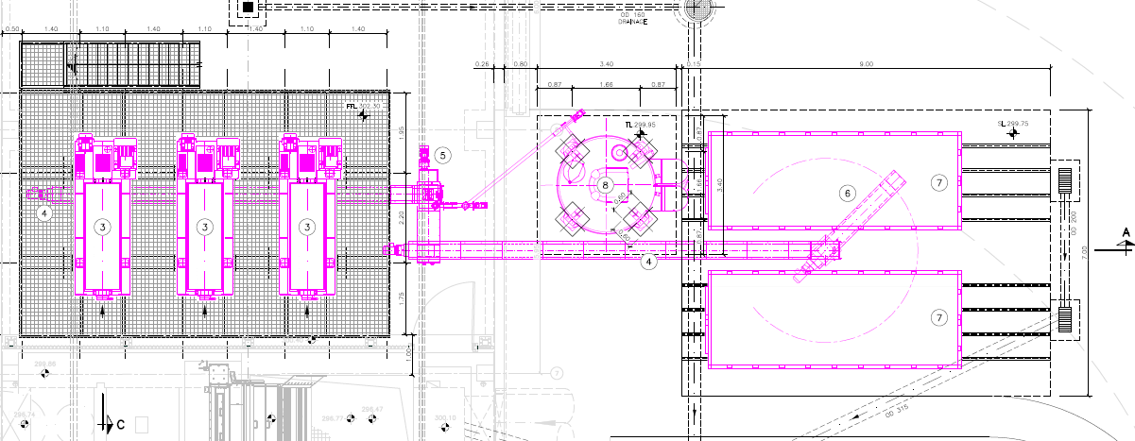

5.4. POLYELECTROLYTE DOSAGE

For both stages, the equipment of the polyelectrolyte dosage is the same and its characteristics are:

• Quantity of equipment: 1 unit.
• Unitary capacity: 8,000 l/h
• Polyelectrolyte type: Powdered polyelectrolyte
• Concentration: 0.5%
• Preparation tank capacity: 8,000 liters.
• Number of mixers: 2 units.
• Motor/mixer: 1.10 + 0.75 kW - IP55-1,400 rpm

The dosage will be carried out by:

• 2 (1+1) progressive cavity pumps in “current stage”
• 3 (2+1) progressive cavity pumps in “first extension stage” With the following characteristics:
• Unitary flow: 1,400-3,700 l/h,
• Pressure: 10 w.c.m.
• Unitary power: 1.1 kW
• Equipped with VFD

All of this equipment is located in the garage of the existing fine screen building.

5.5. LIME STABILIZATION

Lime stabilization facility is the same for both stages, but the required dose is different:

• In “current stage”: 250 kg/t D.S, with a storage time of 5 days.
• In “first extension stage”: 125 kg/t D.S, with a storage time of 6 days.

Storage of product is made in a cylindrical vertical silo, dimensions according to suit required autonomy. Equipped with the necessary elements for correct and safe operation: filling pipe, ladder to roof with protection, handrails, dust filter, level detectors, pressure valve, and rapid opening airtight manhole. This silo is placed on a concrete slab.

Storage silo:

• Diameter: 2,400 mm
• Product outlet flange height: 2,000 mm
• Conical height: 1,955 mm
• Cylindrical height: 8,500 mm
• Total height: 13,555 mm
• Filling pipe: DN80
• Material body: Carbon steel
• Equipment:
o Dust collector
o 2 level detectors
o Under pressure – overpressure relief valve

The arch breaker and dosing unit performs a volumetric dosing of product. The dosage is controlled by a variable frequency drive acting on the metering screw.

Connected in series with the metering screw, a conveyor screw and an injector ID transport and introduce the product in the mixer. The configuration of this set of screws are designed to prevent clogging by moisture / steam generated inside the mixer.

The mixer, with double helix rotor counter-rotating blades and discontinuous, get a homogeneous mixture. The speed / flow process varies by frequency converting.

Sludge mixing system:

Set of equipment for mixing sludge with calcium oxide, comprising input hopper sludge with level detector, twin rotor mixer and collection system and washing powder.

• Process capability: 11 m3/h (max lime + sludge)

Electric control panel with PLC and touch screen modes local / remote operation, and possibility to control the dosage of mixture based on an external variable (4-20 mA).

5.6. SWITCHBOARDS ROOM

The switchboards room is located in the garage of the existing fine screen building. The dimensions of the electrical room are the same for both stages, being its dimensions:

• L = 6.00 m
• W = 3.00 m
• H = 3.50 m

Inside the electrical room, there is a raised false floor, 0.40 m height, for the passage of cables and MCC assembly.

1. CURRENT STAGE
SLUDGE TO FEEDING SLUDGE BUFFER TANK  Weight of sludge to dewatering facility: | 25.600,00 | kg/d
Concentration: | 40,00 | kg/m³
Volume of sludge to dewatering facility: | 640,00 | m³/d
Operating hours per day: | 5,00 | h/d
Required capacity: | 133,33 | m³
Nº of tank: | 1 | ut
Length: | 11,00 | m
Width: | 5,00 | m
Useful height: | 2,65 | m
Adopted capacity: | 145,75 | m³/d
Retention time: | 5,47 | h
Type of mixer: Submersible mixer
Nº of mixer: | 1 | ut
SLUDGE DEWATERING
Weight of sludge to dewatering facility: | 25.600,00 | kg/d
Volume of sludge to dewatering facility: | 640,00 | m³/d
Concentration: | 40,00 | kg/m³
Operating days per week: Page 2 of 13 | 7 | d/w
Operating hours per day: | 16,00 | h/d
Operating load per working day: | 25.600,00 | kg/d
Operating load per working hour: | 1.600,00 | kg/h
daily volume to treat per working day: | 640,00 | m³/d
Volume to treat per working hour: | 40,00 | m³/h
FEED TO CENTRIFUGES
Weight of sludge to dewater pe working day: | 25.600,00 | kg/d
Concentration: | 40,00 | kg/m³
Daily volume per working day: | 640,00 | m³/d
Minimum pumping time: | 16,00 | h/d
Maximum demanded flow per working hour: | 40,00 | m³/h
Type of pumps: Progressive cavity pump
Total number of installed pumps: | 2 | uts
Number of pumps on duty: | 1 | ut
Number of stand-by pumps: | 1 | ut
Maximum unitary flow required per working hour: | 40,00 | m³/h
Maximum unitary flow adopted per working hour: | 45,00 | m³/h

Type of control:
Range regulation: Control system: Destination:
Automatic proportional to the flow
Automatic 4 ÷ 20 mA signal Frequency converter Dewatering centrifuges
Number of flowmeters: 1 ut
Type of flowmeter:
Flowmeter diameter: | 100 | mm
Average speed: | 1,59 | m/s

Electromagnetic in pipe

POLYELECTROLYTE SOLUTION - PREPARATION AND DOSING

Reagent:
Polyelectrolyte

Doses and Consumption
Dry matter to treat
• By design: 1.600,00 kg/h
• Maximum by pumping: 1.800,00 kg/h
Dose
• Average: 8,00 kg/tn
• Maximum: 10,00 kg/tn
Hourly consumption at maximum load by pumping
• Average: 14,40 kg/h
• Maximum: 18,00 kg/h
Daily consumption
• Average: 204,80 kg/d
• Maximum: 256,00 kg/d

Storage of powdered product
Type of supply:

Solid
Commercial product purity: 100 % Density: 0,50 kg/l Autonomy of storage by average dose: 15,00 d Required capacity: 3.072,00 kg Adopted capacity: 3.100 kg

Dilution
Preparation system:

Automatic
Number of installed equipments: 1 ut
Number of equipments on duty: 1 ut
System:
Required capacity
• Average: | 14,40 | kg/h
• Maximum: | 18,00 | kg/h
Dilution concentration: | 0,50 | %
Number of dilution equipments on duty: | 1 | ut
Number of compartments for each tank: | 3 | uts
Number of dilution mixers per equipment: | 2 | uts
Required capacity
• Average dose: | 2.880,00 | l/h
• Maximum dose: | 3.600,00 | l/h
Adopted capacity: | 8.000 | l/h
Volume: | 8.000 | l
Maturation time: | 30 | min

Volumetric dosing

Dosing
System:

Progressive cavity pump
Total number of installed pumps: 2 uts Total number of pumps on duty: 1 ut Total number of stand-by pumps: 1 ut Maximum unitary flow demanded: 3.600,00 l/h Maximum unitary flow adopted: 3.700 l/h Range of flow adopted: 1.400 - 3.700 l/h
Type of dosage: Range adjustment: Control system:
Post-dilution to dosage "in line":
Automatic proportional to the flow
Automatic 4 ÷ 20 mA signal
Frequency converter
• Secondary dilution concentration in line: 0,20 %
• Maximum unitary flow water for dilution: 5.550 l/h
• Measurement system:
Variable area flowmeter
• Number of installed rotameters: 1 ut
• Number of rotameters on duty: 1 ut
• Required unitary flow: | 5.550 | l/h
• Unitary flow adopted: | 500 - 6.300 | l/h
CENTRIFUGES
Total weight of sludge to dewater per working day: | 25.600,00 | kg/d
Concentration: | 40,00 | kg/m³
Daily volume per working day: | 640,00 | m³/d
Maximum flow of sludge by pumping per hour: | 40 | m³/h
Load of sludge to Qmax per working hour: | 1.600,00 | kg/h
Number of centrifuges on duty: | 1 | ut
Number of stand-by centrifuges: | 0 | ut
Unitary required capacity design
• Dry matter of sludge to dewater per hour: | 1.600,00 | kg/h
• Flow of sludge to dewater per working hour: | 40,00 | m³/h
Unitary required maximum capacity by pumping
• Dry matter of sludge to dewater per hour: | 1.600,00 | kg/h
• Flow of sludge to dewater per working hour: | 40,00 | m³/h
Unitary real adopted capacity
• Dry matter of sludge to dewater: | 1.650 | kg/h
• Flow of sludge to dewater: | 45 | m³/h
DEWATERED SLUDGE
Solid retention performance in centrifuges: | 95,00 | %
Weight of dewatered sludge per working hour: | 24.320,00 | kg/h
Final dry solids content of dewatered sludge: | 25,00 | % by weight
Weight of the cake per working day: | 97,28 | tn/d
Density of the dewatered sludge: | 1,10 | tn/m³
Flow of sludge: | 88,44 | m³/d

DEWATERED OVERFLOW
Daily volume per working day: 551,56 m³/d
Maximum flow per working hour: 33,78 m³/h
Evacuation system: Destination:
Gravity
Fine screen
Weight of S.S.in supernatant per working hour: 1.280,00 kg/h
Concentration of S.S.in supernatant: 2,32 kg/m³

STABILIZATION OF DEWATERED SLUDGE
Weight of sludge to stabilize: 1.600,00 kg/h
Dewatered sludge flow per working day: 88,44 m³/d
Type of reagent:
Quicklime (calcium oxide)

Lime dosing
Type of supply:

Solid
Richness: 100,00 %CaO Specific mass: 0,90 kg/l

Consumption
Dose design: 250 kg/tn
Daily consumption: 400,00 kg/h

Storage
Type of storage:

Silo
Autonomy of storage to design dose: 5 d Number of silos: 1 ut unitary capacity required: 35,56 m3
Silo capacity adopted: 42 m3

Dosificación
System:

Metering conveyor
Nº of metering conveyor: 1 ut Unitary required capacity: 400,00 kg/h Metering conveyor capacity: 400 kg/h

MIXTURE OF SLUDGE AND QUICKLIME
Flow of sludge to mix: 5,53 m³/h Reagent flow: 0,44 m³/h Total flow of mix: 5,97 m³/h Mixing equipment
• System:
• Operation:
• Number of installed mixers: | 1 | ut
• Required capacity: | 5,97 | m³/h
• Mixer capacity: | 7,00 | m³/h

Sludge mixer
Continuous

DEWATERED SLUDGE AND STORAGE
Dewatered sludge flow: 5,97 m³/h
Dewatered sludge extraction:
Container
Nº of containers: 2 uts
Container capacity: 20,00 m³
Total storage capacity: 40,00 m³
Total storage time: 6,70 h
Stabilized sludge destination: Drying bed

2. FIRST EXTENSION STAGE
SLUDGE TO FEEDING SLUDGE BUFFER TANK  Weight of sludge to dewatering facility: | 47.952,20 | kg/d
Concentration: | 40,00 | kg/m³
Volume of sludge to dewatering facility: | 1.198,81 | m³/d
Operating hours per day: | 2,70 | h/d
Required capacity: | 134,87 | m³
Nº of tank: | 1 | ut
Length: | 11,00 | m
Width: | 5,00 | m
Useful height: | 2,65 | m
Adopted capacity: | 145,75 | m³/d
Retention time: | 2,92 | h
Type of mixer: Submersible mixer
Nº of mixer: | 1 | ut
SLUDGE DEWATERING
Weight of sludge to dewatering facility: | 47.952,20 | kg/d
Volume of sludge to dewatering facility: | 1.198,81 | m³/d
Concentration: | 40,00 | kg/m³
Operating days per week: | 7 | d/w
Operating hours per day: | 16,00 | h/d
Operating load per working day: | 47.952,20 | kg/d
Operating load per working hour: | 2.997,01 | kg/h
daily volume to treat per working day: | 1.198,81 | m³/d
Volume to treat per working hour: | 74,93 | m³/h
FEED TO CENTRIFUGES
Weight of sludge to dewater pe working day: | 47.952,20 | kg/d
Concentration: | 40,00 | kg/m³
Daily volume per working day: | 1.198,81 | m³/d
Minimum pumping time: | 16,00 | h/d
Maximum demanded flow per working hour: | 74,93 | m³/h
Type of pumps: Progressive cavity pump
Total number of installed pumps: | 3 | uts
Number of pumps on duty: | 2 | uts
Number of stand-by pumps: | 1 | ut
Maximum unitary flow required per working hour: | 37,46 | m³/h
Maximum unitary flow adopted per working hour: | 45,00 | m³/h

Type of control:
Range regulation: Control system: Destination:
Automatic proportional to the flow
Automatic 4 ÷ 20 mA signal Frequency converter Dewatering centrifuges
Number of flowmeters: 2 uts
Type of flowmeter:
Flowmeter diameter: | 100 | mm
Average speed: | 1,59 | m/s

Electromagnetic in pipe

POLYELECTROLYTE SOLUTION - PREPARATION AND DOSING

Reagent:
Polyelectrolyte

Doses and Consumption
Dry matter to treat
• By design: 2.997,01 kg/h
• Maximum by pumping: 3.600,00 kg/h
Dose
• Average: 8,00 kg/tn
• Maximum: 10,00 kg/tn
Hourly consumption at maximum load by pumping
• Average: 28,80 kg/h
• Maximum: 36,00 kg/h
Daily consumption
• Average: 383,62 kg/d
• Maximum: 479,52 kg/d

Storage of powdered product
Type of supply:

Solid
Commercial product purity: 100 % Density: 0,50 kg/l Autonomy of storage by average dose: 15,00 d Required capacity: 5.754,26 kg Adopted capacity: 6.000 kg

Dilution
Preparation system:

Automatic
Number of installed equipments: 1 ut
Number of equipments on duty: 1 ut
System:
Required capacity
• Average: | 28,80 | kg/h
• Maximum: | 36,00 | kg/h
Dilution concentration: | 0,50 | %
Number of dilution equipments on duty: | 1 | ut
Number of compartments for each tank: | 3 | uts
Number of dilution mixers per equipment: | 2 | uts
Required capacity
• Average dose: | 5.760,00 | l/h
• Maximum dose: | 7.200,00 | l/h
Adopted capacity: | 8.000 | l/h
Volume: | 8.000 | l
Maturation time: | 30 | min

Volumetric dosing

Dosing
System:

Progressive cavity pump
Total number of installed pumps: 3 uts Total number of pumps on duty: 2 uts Total number of stand-by pumps: 1 ut Maximum unitary flow demanded: 3.600,00 l/h Maximum unitary flow adopted: 3.700 l/h Range of flow adopted: 1.400 - 3.700 l/h
Type of dosage: Range adjustment: Control system:
Post-dilution to dosage "in line":
Automatic proportional to the flow
Automatic 4 ÷ 20 mA signal
Frequency converter
• Secondary dilution concentration in line: 0,20 %
• Maximum unitary flow water for dilution: 11.100 l/h
• Measurement system:
Variable area flowmeter
• Number of installed rotameters: 2 uts
• Number of rotameters on duty: 2 uts
• Required unitary flow: | 5.550 | l/h
• Unitary flow adopted: | 500 - 6.300 | l/h
CENTRIFUGES
Total weight of sludge to dewater per working day: | 47.952,20 | kg/d
Concentration: | 40,00 | kg/m³
Daily volume per working day: | 1.198,81 | m³/d
Maximum flow of sludge by pumping per hour: | 74,93 | m³/h
Load of sludge to Qmax per working hour: | 2.997,01 | kg/h
Number of centrifuges on duty: | 2 | uts
Number of stand-by centrifuges: | 1 | ut
Unitary required capacity design
• Dry matter of sludge to dewater per hour: | 1.498,51 | kg/h
• Flow of sludge to dewater per working hour: | 37,46 | m³/h
Unitary required maximum capacity by pumping
• Dry matter of sludge to dewater per hour: | 1.498,51 | kg/h
• Flow of sludge to dewater per working hour: | 37,46 | m³/h
Unitary real adopted capacity
• Dry matter of sludge to dewater: | 1.650 | kg/h
• Flow of sludge to dewater: | 45 | m³/h
DEWATERED SLUDGE
Solid retention performance in centrifuges: | 95,00 | %
Weight of dewatered sludge per working hour: | 45.554,59 | kg/h
Final dry solids content of dewatered sludge: | 25,00 | % by weight
Weight of the cake per working day: | 182,22 | tn/d
Density of the dewatered sludge: | 1,10 | tn/m³
Flow of sludge: | 165,65 | m³/d

DEWATERED OVERFLOW
Daily volume per working day: 1.033,15 m³/d
Maximum flow per working hour: 62,49 m³/h
Evacuation system: Destination:
Gravity
Fine screen
Weight of S.S.in supernatant per working hour: 2.397,61 kg/h
Concentration of S.S.in supernatant: 2,32 kg/m³

STABILIZATION OF DEWATERED SLUDGE
Weight of sludge to stabilize: 2.997,01 kg/h
Dewatered sludge flow per working day: 165,65 m³/d
Type of reagent:
Quicklime (calcium oxide)

Lime dosing
Type of supply:

Solid
Richness: 100,00 %CaO Specific mass: 0,90 kg/l

Consumption
Dose design: 125 kg/tn
Daily consumption: 374,63 kg/h

Storage
Type of storage:

Silo
Autonomy of storage to design dose: 6 d Number of silos: 1 ut unitary capacity required: 39,96 m3
Silo capacity adopted: 42 m3

Dosage
System:

Metering conveyor
Nº of metering conveyor: 1 ut Unitary required capacity: 374,63 kg/h Metering conveyor capacity: 400 kg/h

MIXTURE OF SLUDGE AND QUICKLIME
Flow of sludge to mix: 10,35 m³/h Reagent flow: 0,42 m³/h Total flow of mix: 10,77 m³/h Mixing equipment
• System:
• Operation:
• Number of installed mixers: | 1 | uts
• Required capacity: | 10,77 | m³/h
• Mixer capacity: | 11,00 | m³/h

Sludge mixer
Continuous

DEWATERED SLUDGE AND STORAGE
Dewatered sludge flow: 10,77 m³/h
Dewatered sludge extraction:
Container
Nº of containers: 2 uts
Container capacity: 20,00 m³
Total storage capacity: 40,00 m³
Total storage time: 3,71 h
Stabilized sludge destination:
Drying bed

